Bachelor Thesis: Observed Effects of Gamification on Students’ Holistic Development

Hannah N. Taylor
NHL Stenden University
International Teachers Education for primary schools (ITEps)
First Assessor: James Denby
Second Assessor: Margaretha de Mooij
June 8, 2020

Abstract
This paper analyses the effects of using gamification in an educational context to mediate learning behaviours and attitudes. Particularly, the relationships between the independent variables of game mechanics, elements, and dynamics (MEDs) and the dependent variables of student holistic development. To identify these effects, quantitative and qualitative observations were collected from three class teachers of a 12-student class during the implementation of gamified International Primary Curriculum (IPC) unit. Conclusions were drawn from this data using a 4-phase constant comparative analysis and manual coding through an interpretivist perspective. Analysis of the results suggested 31 possible relationships between the identified holistic development constructs and influencing factors, such as game MEDs, Online Learning, Topic, and Time of Year. Interpreting the outcome from the effects of these relationships, 15 were positive, 4 negative, and 12 had an indeterminable effect due to contradicting or insufficient data. Gamification appeared to have had the most effect on students’ holistic development with a total of 20 out of the 31 possible relationships connecting to at least one game dynamic. Interest & Motivation, Perseverance, Problem Solving & Critical Thinking, and Attendance were the most notable constructs in connection to gamification. Overall, gamification was observed to have had a mostly positive effect on students’ holistic development. However, considering the small context and multiple limitations of this study, it was not possible to conclude any direct causality of gamification. Moving forward, it was concluded that there is a need for future research into the causal relationships of gamification to the holistic development constructs identified to have had an effect in this study.
Key words: Gamification, Holistic Development, Mediating Process, Constant Comparative Analysis, Interpretivist, International Primary Curriculum

Contents
Introduction 4
Objectives 4
Motivation 4
Research Questions 5
Significance 5
Literature Review 5
Defining Gamification and Relevant Terminology 5
Games and Gamification in Previous Educational Practice 6
Considerations on Critical Views and Issues of Gamification 7
Creating a Gamification Framework for Implementation 7
Gamification Design Considerations 8
Creating a Theory-Based Holistic Assessment 9
Research Design 10
Participants and Context 10
Methodology 10
Data Collection & Analysis 11
Results 13
Description of the Data 13
Analysis of the Data 15
Discussion 18
Quality & Limitations 20
Ethics 21
Conclusion 22
Research Conclusion 22
Recommendations for Future Research 23
Tables 25
Figures 30
References 37
Appendix 40

Introduction
“Can you change education at the core?” (TEDx Talks, 2018, 1:24). A seemingly simple, yet extremely complex question to answer when considering the future of education. In context, Scott Hebert proposed this question during his Ted Talk on gamification in 2018 (TEDx Talks). Continuing with the proposal that grades, standards and expectations are “ridiculous” when “[teachers] are dealing with a population that is there to gain knowledge […] in a space that should be free of judgement” (TEDx Talks, 2018, 1:26). This not only raises the question of can you, but also, how do you change education to be more meaningful than: completing assignments because it is required. Additionally, studies on students’ motivation and engagement in school found that traditional teaching methods do not sufficiently engage students or motivate them for the right reasons (Lee & Hammer, 2011). One solution to these issues has been a widely debated topic in recent years: gamification. With both discussion on its definition and effectiveness, gamification has been a consistent talking point this past decade. Though most studies have found gamification to be useful, with positive effects in an educational context, there are many questions yet to be answered and issues to be discussed (Humari, Koivisto, & Sarsa, 2014).

Objectives
Contributing to the discussion, this study aimed to identify the perceived effects of gamification on students’ holistic development. The focus of the research was to interpret correlating relationships of these effects through the analysis of teacher observations, which were collected throughout a 9-week gamified unit. Due to COVID-19, the study was conducted in both a physical classroom and through online learning. Instead of the originally planned collection of student perceptions, it was more accessible to collect observations from the teachers.

Motivation
As Hebert expressed in his TEDx Talk, “the education system [is in an] engagement crisis”, and something must be done about it (TEDx Talks, 2018, 3:24). Specifically, students are getting bored with the current teaching methods. The compartmentalized, rigid, and intangible lessons often provided to students, lack connection to their lives and the real world. Hebert suggested “[teachers] need to make kids believe they are doing something for a reason – for a purpose” (TEDx Talks, 2018, 6:59). Hebert is not alone in the proposal of using gamification as a solution. Some sources even claimed gamification “may be justified as necessary” for the development of 21st century skills (Bicen & Kocakoyun, 2018, p. 73). Examples of such skills can include, preparing “students to think [critically], [work in] alternative atmospheres, and for creating a competitive environment” (Bicen & Kocakoyun, 2018, p. 73). Before research could be conducted, it was important to first define gamification and its formational theory. Furthermore, to assess the effects on students accurately and comparably, this research proposed a holistic assessment framework should be developed and utilized in a gamified unit.

Research Questions
What are the observed effects of gamification on students' holistic development in an IPC classroom and online learning environment?
- What is gamification and how is it defined by the literature?
- How is a gamified unit structured based on theory from existing literature?
- How do you define, measure, and assess holistic development according to the literature?

Significance
Gamification is still in its infancy and, as the literature suggests, there are many aspects still to investigate and considerations to be made when doing so (Landers, 2014; Lee & Hammer, 2011; Humari et al., 2014; Turan, Avinc, Kara, & Goktas, 2016). Identifying the effects of gamification on students’ holistic development widens the knowledge of gamification and its implementation in an educational context. Thus, contributing to the effort of educators finding a solution to the engagement crisis. With the literature suggesting mostly positive cognitive, social and emotional benefits, it proves the importance of deeper and more rigorous research into gamification and its effects (Bicen & Kocakoyun, 2018; Landers, 2014; Lee & Hammer, 2011; Humari et al., 2014; Turan et al., 2016).

Literature Review

Defining Gamification and Relevant Terminology
As widely debated as the topic itself, the definition of gamification, and the terminology used to describe it, has been at the centre of discussion among researchers. As mentioned, care must be taken to efficiently define gamification. Otherwise, the currently varying definitions of gamification may cause varying results and difficulty identifying the causal effects observed in the research (Landers, 2014). Since the creation of the term in 2003 by Nick Pelling, a British game developer, the definition of gamification has been defined as the use of game elements, mechanics and dynamics in a non-game context (Jagušta, Botičkia, & Sob, 2018; Turan et al., 2016; Landers, 2014). More simply put, turning something that is not a game into a game. According to Landers, this definition is “[…] detrimental to the development […]” of research on gamification (Landers, 2014, p. 757). Therefore, the parameters exist in which gamification has been justified to earn a new and theory-based definition.
To begin, there are several terms used in the description and explanation of gamification, which must be defined. As Bicen and Kocakoyun mentioned, there are three aspects of games that are applicable to gamification: mechanics, elements, and dynamics (MED) (2018). Game mechanics refer to the rules and elements (game elements) of the game which the players interact with, and in return influences the behaviours of players (game dynamics) (Bicen & Kocakoyun, 2018; Designing Digitally, 2019; Jagušta et al., 2018; Kim, 2015; Turan et al., 2016). Bunchball, a company that specialises in the creation of gamified education, identified several game dynamics (i.e., collaboration, competition, exploration, etc.) which were adapted in combination with the dynamics included in Bicen and Kocakoyun’s study (i.e., reward, status, achievement) to form the list of dynamics in Table 1 (Bicen & Kocakoyun, 2018; Bunchball, 2019).
Throughout the reviewed studies, there did not seem to be a consensus on which elements are attributed to games. However, there were multiple aspects identified as being relevant to learning. In order to increase the comparability of this study, a list has been compiled as a summary of the possible game elements from various studies and sources on gamification (e.g., Bunchball, 2019; Landers, 2014; Kim, 2015). These game elements, along with their matching game dynamics are listed in Table 1. Highlighted game elements were used in the original design of the study, and elements with an asterisk were either impacted learning or removed completely due to online learning.
Among the debate on a definition for gamification, research literature suggested a more holistic understanding of gamification as a method for learning. Several studies concurred with this notion, adding that gamification is the use of game MEDs to invoke game-like experiences, to influence favourable learning-related behaviours, and to motivate engagement (Bicen & Kocakoyun, 2018; Landers, 2014; Lee & Hammer, 2011; Humari et al., 2014; Jagušta et al., 2018;). Elaborating, Landers stated, “gamification involves the identification, extraction, and application of individual game elements or limited, meaningful combinations of those elements” (2014, p. 754). In agreement with Landers, and summarising the additional literature, the rest of this paper shall refer to gamification under the following definition: Gamification is a method which uses specific limited combinations of game MEDs in a non-game context to influence associated behaviours. Within the context of this study, the non-game context is education and the associated behaviours refers to learning-related behaviours.

Games and Gamification in Previous Educational Practice
In reference to the need for gamification, many studies on games and gamification have resulted in a range of cognitive, emotional, and social benefits when applied in an educational context (Bicen & Kocakoyun, 2018; Turan et al., 2016). Aligning with the definition of gamification, research has shown positive effects of gamification on learning-related behaviours such as motivation, engagement, and participation (Cheong, Cheong, & Filippou, 2013; Huang & Hew, 2015; Lee & Hammer, 2011; Villagrasa, Fonseca, & Redondo, 2014). On the other hand, de-Marcos and colleagues observed their control group to have higher participation than the gamified group (de-Marcos, Domínguez, Saenz-de-Navarrete, & Pagés, 2014). Finding the design may have caused lower participation due to its individual and competitive focus (de-Marcos et al., 2014). This suggests that a competitive game dynamic might not be suited towards all learners and should be carefully considered in the design.
Furthermore, the reviewed literature produced one study, involving gamification in a university course, which found a decrease in satisfaction when compared to students in a traditional course (Hanus & Fox, 2015). However, there may have been a relation to the age of the students in the study and should be considered in future research. Referring to the learning-related behaviours, several other studies did observe gamification to increase students’ interest and therefore motivation to engage and participate in the content (Humari et al., 2014; Jagušta et al., 2018; Lee & Hammer, 2011; Simões, Redondo, & Vilas, in press; Turan et al., 2016). Lee and Hammer claimed gamification not only “motivate[s] students to participate more deeply…” but it can also “…change their self-concept as learners” (2011, p. 2). This lends to the consensus among most studies that gamification can also be beneficial to students’ lifelong perspectives toward learning (Lee & Hammer, 2011). The game MEDs, combined with real-life tasks, not only help students understand and appreciate why they are learning but also what it means to them and their future (Lee & Hammer, 2011). Though the literature revealed some negative results, the majority showed positive effects on students’ learning experiences and behaviours, as well as socio-emotional and cognitive development.

Considerations on Critical Views and Issues of Gamification
Contrastingly, there have been several points of critique in the research and development of gamification. Some critical views refer to the complications of implementing gamification, adverse or short-term effects on students, possible increase in negative behaviours, and the ‘novelty effect’. Tying into the debate on a definition, the implementation of gamification may vary depending on the definition used to design a framework. Therefore, it is understandable why Robertson would claim “gamification is the wrong word for the right idea” and that it should be called “pointsification” (2010). Although the literature review did not produce any examples of gamification using only a point-based reward system in an educational context, it is possible that this may have been the design for other studies in education or business.
Regardless, as mentioned by both Nicholson and Robertson, using a points system “needs to be implemented carefully with due concern for appropriateness and for unintended consequences” (Nicholson, A RECIPE for Meaningful Gamification; Robertson, 2010). Such unintended consequences may include the critical points addressed in Table 2 (Bicen & Kocakoyun, 2018; Hanus & Fox, 2015; Humari et al., 2014; Jagušta et al., 2018; Lee & Hammer, 2011; Nicholson, 2010, A RECIPE for Meaningful Gamification; Turan et al., 2016). Likewise, multiple sources raise the point of the “novelty effect” and varying results based on users and context (Humari et al., 2014, p. 3028-3030; Landers, 2014, p. 760-761; Turan et al., 2016, p. 68). Meaning, the new experience may increase certain behaviours, but over time these behaviours return to their original state. Using the definition established in this study and the design solutions listed in Table 2, the research addresses these critiques and issues in the unit design (see also Gamification Design Considerations).

Creating a Gamification Framework for Implementation
In the context of education, the purpose of gamification can be summarised as a method to influence learning-related behaviours in order to indirectly affect learning outcomes of a pre-existing instructional source, using the motivational dynamics of game elements and the application of real-world problems (Humari et al., 2014; Landers, 2014; Lee & Hammer, 2011). Developing a theory of gamification from the literature, required reviewing the two separate, three-construct models proposed by Landers and Humari et al. (Humari et al., 2014; Landers, 2014). From these two ideas, a revised model has been created to form the theory this study is based on (see Figure 1).
Summarising the two theories, this model implies four theorized causal effects involving two independent variables (blue A and B), one dependent variable (yellow), and the Learning Outcomes (red) (Humari et al., 2014; Landers, 2014). Parallel with the identified purpose of using gamification, this theory hypothesizes the correlation between gamification on learning behaviours. Likewise, a correlation between learning behaviours and attitudes on academic achievement or otherwise defined learning outcomes. However, there were few studies which found a direct relation between gamification and student achievement (Bicen & Kocakoyun, 2018; Turan et al., 2016). Additional research should be done explicitly into this relationship once a more comparable framework has been sufficiently developed. Though, for the purpose of this study only the relationship between game MEDs and learning behaviours and attitudes was analysed. Finally, this theory suggests game MEDs do affect learning behaviours and attitudes if the lessons are already well-designed for academic success. If the content is not well-designed, then gamification will not increase learning outcomes (Landers, 2014). Finally, Landers stated there are two proposed processes in which game MEDs affect learning: “a more direct mediating process and a less direct moderating process”, which “form the foundation of the theory of gamified learning” (2014, p. 760).
The first process refers to proposal 2, and suggests gamification is successful via mediation if the game MEDs “cause the target [learning-related] behavior” (Landers, 2014, p. 763 & 765). The second process refers to proposal 4, and suggests gamification is successful via moderation if the “target [learning-related] behavior [increases] learning [outcomes]” (Landers, 2014, p. 763). In other words, gamification can be successful when approached via moderation of pre-existing and well-designed instructional content, and via mediation when the goal of the design aims to change a “learning-related behavior” (Landers, 2014, p. 763). According to Landers, the most common application of gamification is the mediational approach where “[t]he relationship between game [dynamics, mechanics and] elements and learning outcomes is mediated by behaviors/attitudes” (2014, p. 762). However, it is important to consider the relationship mentioned in proposals 1 and 3, which address the influence of instructional content design on student behaviours and attitudes, as well as their learning outcomes. Relating to the issues of participation, engagement, and motivation, students may have different preferences of themes or subjects which can initially raise or lower their interest to learn a topic. Similarly, if the instructional content design has not already proven to be successful in positive learning outcomes, adding gamification will not have an effect on learning outcomes.

Gamification Design Considerations
Furthermore, four main critical points have arisen from the literature; these effects should be investigated and considered for the advancement of gamification. These are listed in Table 2 alongside the design solutions for this study. Some of these points include adverse emotional effects due to removal of gamification or the increased cognitive load, anxiety, stress, or negative behaviours. This is considered in the design and constant comparative analysis will aid in constantly observing for these negative changes and the possible need for intervention.
Another highly recommended suggestion for designing and research of a gamified unit, lesson or activity is to choose a “meaningful combination of [game] elements” and to explicitly observe their relation within the mediating and moderating processes (Jagušta et al., 2018; Landers, 2014, p. 763, 764 & 768). This is the reason why the focus of this study was not on the academic achievement or other learning outcomes in this process. Rather, the data analysis explicitly interpreted the mediating process of relationships between the independent and dependent variables produced from the data. In the context of this study, the gamified unit was created using the highlighted (yellow) game elements in Table 1. Although there was a short time available to conduct this study, there were game elements implemented from each of the game dynamic categories. However, due to the need to define gamification on the fine line between serious games and pointsification, this can be justified as a reasonable amount of game elements to be more than just a reward-based system and less than a serious game (Landers, 2014; Robertson, 2010). As suggested in Table 2, a comparable framework for holistic assessment of the effects of gamification should be developed and results should be analysed with user qualities and context in mind. For a theoretically based and holistic assessment to be designed, it was important to define and understand how to assess holistic development.

Creating a Theory-Based Holistic Assessment
Holistic assessment can be defined as: a paradigm which “aims to address education in terms of the student as a whole” (Williams & Hin, 2015, p. 389). Rather than standardized or summative assessment which is commonly found in traditional teaching methods, it recognizes the unique needs and goals of a student, consequently creating a bigger picture of student development through a formative collection of evidence and often over a longer period. (Williams & Hin, 2015). Relating to the real-world task experienced in gamification, "holistic assessment [helps] to ensure that curriculum is designed to manifest real world tasks and provide challenging situations that stimulate the students" (Akubuilo, 2012, p. 59). A common form of holistic assessment, that was originally planned for use in this study, is self-assessment. Self-assessment can be a beneficial form of task- and construct-based, holistic assessment. As, it can encourage students to be more involved in and aware of their own learning, promote autonomy, help students recognize their strengths and weaknesses, and understand criteria to make judgements on their own learning (Akubuilo, 2012; Singh, Ong, & Singh, 2019; Williams & Hin, 2015). Unfortunately, due to the change in context there was a necessary change in data collection from self-assessments to third-person observations. Although some critics suggest holistic assessment can be flawed, as its essence is not student-driven, Williams & Hin explained the initial stages of implementing holistic assessment will generally be teacher-designed to model the new form to students (2015).
For the purpose of this study, the constructs of student development used to measure holistic development are listed in Table 3. The categories and constructs were compiled as aspects of holistic development based on research suggestions in the literature review (e.g., Turan et al., 2016; Williams & Hin, 2015), IPC Unit learning goals for the Milepost 3 unit Space Explorers, and IPC behaviours learning goals (Fieldwork Education, 2019, “Space Explorers”; Fieldwork Education, 2019, About the IPC). The list also consists of supposed benefits of gamification proposed by the literature (e.g., collaboration, perseverance, and problem-solving.) Although identified as a category of holistic development, student academic achievement will not be measured. Rather, the learning behaviours and attitudes which have been found to impact student academic achievement.

Research Design

Participants and Context
It is important to recognize this was a small-scale study in an English-speaking, international primary school in the Netherlands. The school consisted of four classes with a rough average of 12-16 students per class and followed the IPC curriculum. In particular, the class participating in this study consisted of 12 students from the ages of 9 to 11 (year 5 and 6 according to the National Curriculum for England). Due to differing abilities and other private concerns, two of the students were not included in the study. Therefore, this study will consist of a group of 10 students to be observed.
In the original plan, the same class would have participated in both a control and an experimental unit. In both units, the students would have been issued a weekly self-assessment. This data would have then been compared to answer the initial research question. Due to a series of unprecedented issues, such as the language ability of the class hindering their ability to complete the self-assessments and a sudden enforced switch to distance learning, the design and methodology required adaptations.
Among those adaptations, one of the most notable is the change of participants and data collection. Instead of the students completing a self-assessment, data was collected in the form of observations from the class teachers. There were three observers in total, the researcher and the two class teachers. The researcher had been established as an additional class teacher prior to the experiment beginning to ensure a comfortable relationship with the students. Though classes were taught in English, there were mostly non-native speakers in the class. Students had significant previous experience of using a laptop and internet, and some students have had prior experience working with the researcher as a student-teacher the previous year. Equally important to note is the time of year in which the study was conducted: the school year started in September and ended in June, with the experiment beginning around the end of February.

Methodology
As there are several limitations and constraints of this study, the research was conducted from the interpretivist paradigm, which acknowledges the observer effect (among other issues) on outcomes and aims “to explore perspectives and shared meanings […] to develop insights into situations” (Wellington, 2015, p. 26-27). Furthermore, as this “research involve[d] the manipulation of an independent variable […]” (e.g., game MEDs and instructional content) “without the random assignment of participants”, the research followed a quasi-experimental design (Price, Jhangiani, & Chiang, 2016; Trochim, 2020). As explained in Price, et al.,
[q]uasi-experimental research eliminates the directionality problem because it involves the manipulation of the independent variable. It does not eliminate the problem of confounding variables, however, because it does not involve random assignment to conditions. For these reasons, quasi-experimental research is generally higher in internal validity than correlational studies but lower than true experiments (2016).
Specific limitations which have been identified, are addressed by researching from an interpretivist paradigm. These limitations include the following aspects which were considered during data analysis and should be considered when comparing these results to another study:
- Small-scale,
- Design-based research,
- And mixed contexts (physical and online.)
These will be further discussed in the section Quality and Limitations.

Data Collection & Analysis
In order to identify the possible effects of gamification on students’ holistic development, data was collected in the form of observations from the researcher and two class teachers. The use of observations from three participants ensured inter-rater reliability, which “addresse[d] the issue of consistency of the implementation of a rating system”, and was important to increase the accuracy, quality, and comparability of the study (Lange, 2011). By using the average trends in the data from all three participants, the analysis should have been a more accurate portrayal of the true situation with less room for bias.
There were two stages of data collection: during the experiment and immediately following its conclusion. During the experiment, the participants completed a weekly holistic development assessment rubric per student. The participants graded the students on their holistic development, based on their own observations and perceptions, using the school’s Likert-like grading scale:
- Need Extra Help
- Beginning
- Satisfactory
- Good
- Outstanding
By using a scale which participants were already familiar with, it allowed for more accurate and consistent responses. Each holistic development construct, as identified in the section Creating a Theory-Based Holistic Assessment, was included in this assessment. The second stage of data collection, at the end of the experiment, was done through a questionnaire using Google Forms. Questions in the questionnaire were a mix of closed and open questions that were sectioned by holistic development category. As this questionnaire was focused on identifying the relationships between observed influencers (independent variables) and their effects on the holistic development constructs (dependent variables), this data was used to form a context around the numerical observations in the first stage.
A systematic, reflective, and reflexive analysis of the data was conducted using manual coding and constant comparative analysis to identify relevant data for the purposes of this study (Cobb et al., 2016; Wellington, 2015). The categories were formed “a priori” via the literature review, as shown in Table 3 (Wellington, 2015). Additional categories, constructs, or variables were also expected to have possibly appeared “a posteriori” through the constant comparative analysis of the data (Wellington, 2015). According to the theorized process in Figure 1, the implemented game dynamics and elements are one of the independent variables which should have influenced the holistic development constructs (dependent variables – learning related behaviours and attitudes.) By identifying which holistic development constructs were affected and which variables may have influenced that effect, relationships between the variables were expected to be concluded. Therefore, answering the main question about the effects of gamification on students’ holistic development. To do this, there were four phases of data analysis:
- Phase 1: Calculate Averages of Holistic Assessment Data
  - Data Set 1A: Average observer grade per week
  - Data Set 1B: Average individual student grade per time frame
  - Data Set 1C: Average class grade per time frame
  - Data Set 1D: Average change in individual student grade per construct
  - Data Set 1E: Average change in class grade per construct
- Phase 2: Coding Responses to Questionnaire for Construct and Game Dynamic Frequency and Effect Contexts (Identify Relationships to Influencing Variables)
  - Data Set 2A: Frequency and Context of Holistic Development constructs
  - Data Set 2B: Frequency and Context of Game Dynamics
  - Data Set 2C: Frequency and Context of relationship between constructs and influencing variables
- Phase 3: Rank Identified Possible Effects Based on Most Observable Change per Construct (Assessment & Questionnaire Data)
- Phase 4: Analyse Trends, Plausible Correlation or Causation
To begin, Phase 1 resulted in the creation of five data sets using the holistic assessment data. First, the weekly grades needed to be averaged from the grades given from each observer (1A.) Then, this data was used to create tables which consist of the average grade of each student in each construct per week, per unit half, and before and after the change to online learning (1B.) Once created, this second data set was used to find the average grade of the class for the same time frames (1C.) The final two data sets consisted of the average change in grade per construct for each student and for the class as a whole (1D and 1E.) These changes were calculated by finding the average change in each time frame, then finding the average of those results. Phase 2 used the data from the questionnaire to create two data sets regarding the individual frequency and context of the holistic development constructs and implemented Game Dynamics (2A and 2B.) An additional data set was created which consists of the frequency and context of the relationship between holistic development constructs and suggested influencers (2C.) Using the average change data sets from Phase 1 (1D and 1E) and the individual frequency and context of constructs data set from Phase 2 (2A), Phase 3 compared the data using a table to display the most observable change in holistic development aspect per data set. Finally, the last phase utilized the table from Phase 3 and the relationship data set from Phase 2 (2C) to analyse trends and interpret plausible correlation or causation where possible. By comparing the four data sets (1D, 1E, 2A, 2C), it should have allowed for better insight into the true possibility of any identified relationships and eliminated the possibility of an unjust conclusion from a singular, insufficient set of data.

Results

Description of the Data
The first Phase of data analysis resulted in several tables of raw data which may be requested from the researcher (see appendix) and the summarized information which can be found in Figure 2. The figure represents the data sets 1D and 1E, the average change in grade per construct for individual students and the class average. The chart was created by finding the number of students who had a positive and negative average change of grade in each construct, which can be found on the X-axis. Then, the results were paired with the class average change for each construct on the Y-axis. Finally, the results were arranged from the most positive class average change, to the most negative class average change.
Looking at Figure 2, a few things are immediately clear. According to the class average change, Perseverance was the most positively affected construct (0.31-point average change in grade) and Attendance was the most negatively affected construct (-0.67-point average change in grade.) Similarly, according the individual student grades, the most negatively affected construct was Interest & Motivation with 8 out of 10 students exhibiting a decrease grade (-0.47-point average change in grade.) Only slightly differing between the two data sets was the construct of Relationship with Classmates. The individual grades resulted in the same number of students as Perseverance, 7 out 10, who had a positive increase in grade. Whereas the class average change showed only a slight increase compared to Perseverance.
The second phase of data analysis discovered Achievement & Reward, Competition & Opponent Play, and Expression & Control, to be the most frequently mentioned game dynamics. Achievement & Reward was observed the most frequently in a positive context, with 7 out 10 occurrences in a positive context (Figure 3). Competition & Opponent Play and Expression & Control were close behind with 5 out of 10 occurrences in a positive context (Figure 3). They were also the only three game dynamics also observed in a negative context. Out of the three, the most negatively occurring dynamic was Competition & Opponent Play with an equal number of positive and negative occurrences. Overall, participants observed all game dynamics to have had a mostly positive effect. However, some aspects occurred only once or twice.
Additionally, Phase 2 produced the results found in Figure 4: Frequency and Context of Holistic Development Constructs in Questionnaire Observations. Immediately obvious, the data portrayed Interest & Motivation to be the most frequently mentioned construct and the most observed to have been positively affected with 7 out of the 10 occurrences in a positive context. The remaining occurrences were mentioned with no context at all. Moving down the chart, Problem Solving & Critical Thinking, Perseverance, and Attention & Engagement were the next most mentioned constructs with a total of 8 occurrences each. All three constructs were mostly mentioned in a positive context with Problem Solving & Critical Thinking and Perseverance having 7 occurrences and Attention & Engagement having 6. The remaining occurrences of these constructs were with no context at all. Figure 4 also shows that there were only 5 out of the 20 holistic development constructs which were observed to have been negatively affected. Participation, Reflection, Teamwork, Attendance, and Behaviour each had 1 negative occurrence. Furthermore, Control and Empathy did not occur at all in the questionnaire observations. As with the game dynamics, the participants primarily observed the other constructs to have been positively affected. Though, some constructs were only mentioned once or twice.
The final data set extrapolated in Phase 2 can be seen displayed in the form of two bubble charts in Figure 5 and 6. These charts represent the frequency and context of relationships between holistic development constructs and suggested influencing variables. Both charts were plotted with the X-Axis representing the number of occurrences of the dependent variable in the relationship (holistic development construct), the Y-Axis representing the number of occurrences of the independent variable in the relationship (influencing independent variable), and the size of the bubble representing the number of occurrences of the relationships between the independent and dependent variables. The exact frequency of the relationship can also be found next to the relationship in the label for each bubble. The first chart, Figure 5, consists of the relationships mentioned in a positive context and the second, Figure 6, consists of the negative.
According to Figure 5, the relationship with the most influential (mentioned the most) independent variable and most affected (mentioned the most) dependent variable was Gamification (in general) and Interest & Motivation. Out of the 14 occurrences of Interest & Motivation, only 1 was connected to the Topic only and 2 were connected to the Topic and another gamification aspect. Gamification (in general) and Interest & Motivation, Expression & Control and Problem Solving, Competition & Opponent Play and Interest & Motivation, and Status & Visual Progress and Interest & Motivation were the most frequently mentioned positive relationships (3 occurrences each.) As mentioned, Gamification, in general, was the most frequently occurring independent variable with 14 occurrences. Close behind, with 12 occurrences, is Expression & Control and Achievement & Reward with 9 occurrences. The most frequently occurring dependent variable was Interest & Motivation (14) with Attention & Engagement (10) and Problem Solving & Critical Thinking (9) taking the rank of second and third most occurring. According to Figure 6, the seven possible negative relationships identified were only mentioned once each. The most frequently mentioned independent variable in a negative context was Online Learning, with observations of three different holistic development constructs which may have been affected. The most frequently occurring dependent variable in a negative context was Teamwork, which was observed to have a possible negative connection to Achievement & Reward and Expression & Control. Comparing the data from both charts, a contradiction can be identified: Achievement & Reward and Teamwork. This relationship occurs in both a positive and negative context only once.
Utilizing the data from Figure 2, Figure 3, and Figure 4, Phase 3 involved creating a table to display the most observable change per holistic development construct (Table 4.) To find the most observable change in individual student grades and the questionnaire observations, the number of negative results was subtracted from the number of positive results to provide the difference of change observed. The more positive the result, the more positive change was observed. The more negative the result, the more negative change was observed. Similarly, if the difference is 0, there was either no change or a balanced amount of positive and negative change. Then the class average change, found in Phase 1, was added to show the greatest increase, and decrease per aspect for the whole class.
Reviewing the data sets in Table 4, it can be seen that the observations found Interest & Motivation to be the construct observed in the most positive contexts. However, the individual grades showed the majority of students had the largest negative change compared to other constructs and the Class Grade Average shows the overall class Interest & motivation grade to have had a -0.47-point change. Attendance was not mentioned in the observations, but most students had a decrease in their individual grades with the class average showing a 0.67-point decrease in grade – the largest decrease in all constructs. The written observations mostly portrayed Attention & Engagement in a positive context, but the individual grades and class average show the opposite. The individual grades rank Attention & Engagement as the third most negatively occurring construct with a class average decrease of 0.41 points, just slightly less of a decrease than Interest & Motivation. On the other hand, Perseverance was primarily observed in a positive context, aside from one negative occurrence related to Competition & Opponent Play, ranking it as the 2nd most observed construct in a positive context. Similarly, the individual student grades and class grade average also show a positive change in Perseverance. The individual grades rank Perseverance as the construct with the 2nd highest number of students with a positive change. The class grade average ranks it as the construct with the most positive change, a 0.31 grade increase. Problem Solving & Critical Thinking were observed to have the 3rd most positive change in class grade average and occurred in the 2nd most positive contexts. However, when comparing the individual grades of students, there appeared to be a nearly balanced number of students with positive and negative change in grade. Though, it is important to note that the increase observed in the class average grade was only 0.13, just 0.01 points behind the 2nd rated construct, Relationship with Classmates, and equal change to Writing Skills. Still, these constructs were not in the most observed constructs. There were several more possible effects and relationships which were not included in this summary as there was absolutely no effect observed or the effect was extremely limited.

Analysis of the Data
Overall, it is not possible to determine any causal relationships due to the small amount of data in a small study. However, when focusing on the connection of the independent and dependent variables, multiple possible relationships were identified that suggest Gamification had a mostly positive effect in this context. In total, 33 notable effects on holistic development constructs were interpreted from the data (Table 5). This count is a result of the total relationships between the listed dependent variables and independent variables. Dependent variables with multiple possible influencers were counted individually for each possible relationship. Out of the 33 effects, there were 31 suggested relationships to identified influencers. The outcome of these observed effects varied with 15 Positive, 4 Negative, and 12 which had an indeterminable effect due to contradicting or insufficient data.
Gamification appears to have had the most observed effect on students’ holistic development when compared to the other identified influencers (Table 4.) A total of 20 of the 31 suggested relationships were observed to have had an effect from Gamification; 11 out of the 15 positive relationships, 2 out of the 4 negative relationships, and 7 out of the 12 neutral relationships were connected to at least one aspect of gamification. Although the majority of negative relationships were also connected to gamification, the results suggest multiple aspects of gamification had a greater positive effect in this context.
The most frequently mentioned holistic development construct in relation to gamification, was Interest & Motivation. Particularly, Competition & Opponent Play, and Status & Visual Progress were mentioned both individually and in combination with the other. On the other hand, the individual student and the class average grade change suggests there was an overall negative impact on student Interest & Motivation. Due to the small context and little data, it is difficult to determine exactly why the data differs. It is possible that the gamification aspects did increase Interest & Motivation, but may not have been noticeable due to other influencers (i.e. Natural Loss of Interest, Lack of Close Contact Observations, Online Learning, etc.) The observations may also have been based on the comparison of students’ usual Interest & Motivation at a particular time in a previous unit and not a direct representation of their Interest & Motivation based on a grade for this unit alone. These additional influencers are purely speculation and is not backed by data, but it is a possibility. To further conclude any causal positive or negative relationships is not possible due to the contradicting data.
The most noticeable positive effects of gamification were observed to be on student Perseverance and Problem Solving & Critical Thinking Skills. Perseverance was the only construct which was in the top three of the most occurring positive observations, class grade averages, and individual student grades. It also was the construct with the highest increase in class average grade. The primary influencer mentioned in connection with Perseverance was Gamification, with only one mention of the Topic as an influencer. There were several gamification aspects mentioned in connection, such as Achievement & Reward and Competition & Opponent Play, though only once. This makes it hard to determine a causal relationship, but the data suggests there was an effect on Perseverance, and it was most likely due to a gamification aspect in this context. Though the class grade average only slightly improved and the comparison of individual changes in grade resulted in a balanced number of positive and negative change, Problem Solving & Critical Thinking is one of the constructs with similar data in two data sets and did exhibit change. To determine an exact influencer is difficult as the observations yielded effects from Gamification, Online Learning, and the Topic. However, most occurrences were related to aspects of gamification. Suggesting that if there is a positive causal relationship it was probably with an aspect or aspects of gamification. Particularly mentioned aspects include Expression & Control, Achievement & Reward, and Competition & Opponent Play.
One of the larger contradictions in the data, Attendance was observed to have a positive effect from Competition & Opponent Play and Status & Visual Progress. However, the individual and class average grades portray a decrease in student Attendance. With only one negative relationship mentioned in the written observations, it is possible that Online Learning was so negatively impactful that it overpowered benefits of the gamification. Though, with little data to support that, it is not possible to conclude. Further research should be conducted to see if the results would differ in a context where the learning is fully in a physical classroom.
Furthermore, gamification was observed to have had some positive effect on Reflection, Listening Skills, and Reading Skills. Out of these, Achievement & Reward and Challenge was mentioned in positive connection with Listening Skills and Reading Skills, and Status & Visual Progress were mentioned in connection with Reflection. Aside from Reflection, these constructs appeared to have less of an effect from gamification than the previous 3 constructs explained. The data suggests these relationships are possible, but it is not possible to determine a causal relationship due to the small context of the study.
Gamification was only mentioned in a negative context with constructs which were also mentioned in connection with gamification in a positive context. Specifically, Achievement & Reward were observed to have a negative effect on Teamwork for some students and general aspects of gamification may have been an influence of negative student behaviour. However, both were also observed to have positively affected the respective holistic development constructs. Though there is not much data to prove either a positive or negative causal relationship, it may be possible that gamification both positively and negatively affected student Teamwork and Behaviour.
Finally, in regard to the effects from Gamification, 7 out of the 12 inconclusive relationships were in connection to at least one aspect of gamification. Three of which were connected to the aforementioned, Interest & Motivation, while the other relationships were to Attention & Engagement, Participation and Preparation. Within Attention & Engagement and Participation there were multiple aspects of gamification which were counted as just one relationship due to their inconclusive nature and multiple other suggested influencers. For example, Achievement & Reward, Exploration, Expression & Control were specifically mentioned in positive connection with Attention & Engagement. Participation was mentioned in connection with Achievement & Reward and Expression & Control. Both constructs were also suggested in connection to other possible influencers: Topic, Online Learning and one mention of only the Topic with no gamification aspects. Although all observations of these constructs (except one occurrence which observed a negative relationship between Participation and Online Learning) were positive, both the individual and class average grade portray a negative change. Similarly, Preparation was observed to have had a positive change in relation to Competition & Opponent Play and Status & Visual Progress. However, the individual and class grade average also portray a negative change. With Attention & Engagement holding the rank of 3rd greatest negative change and Participation and Preparation holding the 5th greatest negative, it is plausible to claim these constructs may have been negatively affected in this context. Nonetheless, with the written observations primarily suggesting positive relationships, it is not possible to determine any causal positive or negative relationships with these constructs. Therefore, these relationships were determined inconclusive due to contradicting and insufficient data.
As mentioned, the written observations suggested Online Learning to possibly have a negative relationship with Attendance, and an inconclusive relationship with Attention & Engagement and Participation. Furthermore, Online Learning was observed to possibly have had a positive relationship with the constructs of Relationships with Classmates, Speaking Skills, Teamwork and Writing Skills. Particularly, the observations suggested the online learning environment created a context where students needed to clearly express themselves and help each other adapt to a new experience all in a virtual manner. Both students’ Relationships with Classmates and Writing Skills were consistent in all three data sets, suggesting there was a positive change to these constructs in this context. Relationships with Classmates was also the second most improved construct according to the class average grade. In this context, the data suggests there was a positive change to these constructs, and it may have been possible that it was due to Online Learning. Still, there were only singular occurrences of these relationships in the written observations which makes it impossible to determine a causal relationship. Similarly, the relationships to Speaking Skills and Teamwork are not possible to determine a causal relationship due to insufficient data.
The final identified influencer was the Time of Year, which was mentioned in positive connection with Listening and Speaking Skills. Both relationships were mentioned in a single written observation, which suggested that there may have been a natural development and improvement due to students having been in school for several months already that school year. It is likely that with students being surrounded by and practicing English every school day naturally improved their Speaking and Listening Skills. Still, with only one occurrence of this relationship it is not possible to determine the Time of Year to be the cause of the observed positive change.

Discussion
Comparing the analysed results to the literature review, there were a mix of possible conclusions. Although several previous studies found positive effects on students’ Interest & Motivation, Attention & Engagement, and Participation, the data interpreted from this study suggests all three constructs had been both positively and negatively affected (Cheong, C., Cheong, F. & Filippou, J., 2013; Huang & Hew, 2015; Humari et al., 2014; Lee & Hammer, 2011; Jagušta et al., 2018; Simões, J., Redondo, R. D., & Vilas, A. F., in press; Turan et al., 2016; Villagrasa, S., Fonseca, D., & Redondo, E., 2014). As this study produced little data to prove a stronger impact in either direction, the relationships between gamification and these constructs were deemed inconclusive. However, regarding Interest & Motivation, this may be a similar case to that of the study conducted by Jagušta et al., where they determined gamification was not enough to have a significant impact on students’ Interest & Motivation (2018). As mentioned in the analysis section, it is possible the positive effect of gamification on these constructs, which were observed frequently in the questionnaire observations, may have occurred. Though other influencers, such as Online Learning, may have had a more severe negative impact than gamification could with a positive one. In the case of Participation, the literature review revealed examples where gamification negatively impacted participation due to the competitiveness and pressure of the design (de-Marcos et al., 2014). Although there were no direct observations about this relationship in the results of this study, it is possible this may have been an influencing factor for the decrease in participation for some students, and an increase for others.
Additionally, this study has produced some evidence of a negative impact of gamification on student behaviour. This is similar to the results of various previous studies (Bicen & Kocakoyun, 2018; Hanus & Fox, 2015; Humari et al., 2014; Jagušta et al., 2018; Lee & Hammer, 2011; Nicholson, 2010, A RECIPE for Meaningful Gamification; Turan et al., 2016). However, there was only one observation of this relationship (Figure 6) and the other two data sets in Table 4 resulted in an equal number of students with positive and negative change in their behaviour grade (Figure 2). Though there is insufficient data to prove a causal relationship in either context, it is likely that gamification both positively and negatively effects student behaviour but depends on the student.
Showing a more positive impact, Perseverance was the most positively affected construct across all three data sets in Table 4. Though the literature review only revealed one case of this positive effect of gamification, this was the most noticeable impact of gamification interpreted from this study (Lee & Hammer, 2011). Close behind, was the construct of Problem Solving & Critical Thinking. Also supported by the literature in one case, this construct was observed mostly in a positive context with an increase in class average grade (Table 4). Equally important to note is the individual student grades, which suggest there were an equal number of students who were positively and negatively effected in the Problem Solving & Critical Thinking grades. Still, the data in the study has suggested that there is a noticeable positive effect of gamification on students’ Problem Solving & Critical Thinking skills. Particularly, the game dynamic of Expression & Control. In this context, autonomy, choice, and character creation were implemented as part of the Expression & Control game dynamic. Multiple observations in the questionnaire data mentioned the autonomy, choice and independence given by the implemented design of gamification allowed students to take control of their learning by making choices that would affect it without constant guidance from a teacher.
Further conclusions about gamification which may be interpreted from the data include the possible effects of a few particular game dynamics. Though not possible to determine causal relationships with any one holistic development construct, Achievement & Reward, Competition & Opponent Play, and Expression & Control were observed to have had the most effect on students’ holistic development. Out of these three, it is only reasonable to claim Achievement & Reward to possibly have had a more positive effect as the other two have a nearly equal number of positive and negative occurrences.
The literature review did not reveal any evidence regarding the holistic development constructs Relationship with Classmates and Attendance. On the other hand, the data produced in this study suggests they were possibly affected. In a positive context, Relationship with Classmates was found to be the one of the more positively affected constructs, with positive change observed across all three data sets in Table 4. However, there was only one mention of this construct in the questionnaire and it was in connection with the suggested influencer of Online Learning. Contrastingly, Attendance was observed to have been the most negatively impacted construct and the construct with most change in class grade average. The data suggests the primary influencer of a decrease in attendance was Online Learning which overpowered the slightly positive effected observed from Competition & Opponent Play and Status & Visual Progress (Figures 5 and 6). As with all interpreted relationships from this study, the insufficient amount of data due to a small context makes it unjust to prove any causal relationships.
Although it was not possible to prove a causal relationship between gamification and student learning behaviours (holistic development constructs), there was evidence of high correlation. Multiple holistic development constructs were perceived to have changed as a direct result of a game MED. Reflecting on the theorized construct model proposed in Figure 1, it is likely an additional causal relationship should be added. Particularly, that of gamification’s mediating relationship with student learning behaviours and attitudes. As a result, Figure 7 proposes the possible causal relationships observed in this study. As can be seen, Online Learning was also added as an influencing independent variable with two relationships: to the moderating process of gamification and instructional content, and to student learning behaviours and attitudes. This is because of the significant effect of Online Learning observed throughout the study. In future, this model should be considered in the design and analysis of gamification studies in education. However, it may be best to remove the aspect of Online Learning and solely observe the mediating relationship of gamification on student learning behaviours and attitudes.

Quality & Limitations
As mentioned, there are several critical points regarding quality and limitations of this study which were initially identified. To uphold the reliability and validity of the research, a few points should be acknowledged. Firstly, it is of the utmost importance to understand that this research is interpretive. Therefore, analysis and recommendations were the interpretations of the researcher and further interpretations may be possible. Second, data collection has been structured using inter-rater reliability to increase accuracy and quality of the data measurements. Third, though the research acknowledged the possible implications of researcher bias, power imbalance and the observer effect, the possibility of interference was lessened by the students’ previous experience working with the researcher. Additionally, the researcher was in the classroom as the lead teacher for the 9-week duration of the experimental unit. This allowed time for students to build a relationship with the researcher. Regardless, these effects should be considered when comparing the produced data.
Obviously, there was also the limitation of conducting design-based research in a small-scale context. Particularly, when designing a new gamified project, it is possible that the design of the instructional content itself is flawed and therefore gamification would have no effect. This is important to consider when comparing the results of this study. Equally so, with only a small class to observe in a very specific context, the comparability does take a toll.
Moreover, the unprecedented drastic changes instigated by COVID-19 resulted in several unexpected adaptations and limitations for this study. The most significant of which was the change in research design and context. Initially, the study was to take place in a physical classroom. Due to the situation, the study was only in a classroom for the first 3 weeks, and the remaining 6 weeks continued through an online manner. The gamification was upheld by using the website, which was made explicitly for this study, and communication through Google Classroom. However, this presented a few major issues in regard to the study. Instead of the original plan of collecting students’ perceptions of their own holistic development, it was more convenient to use the observations of the teachers as they were more accessible. Because of the necessary change in data collection and the time needed to adjust to it, there were roughly 4-5 weeks of the observations which were retrospective and it is likely that the observations of the participants were limited due to less contact with and the distance from students. Another observed impact on the participants’ observations was the difficulty to distinguish if the work turned in by students was a representation of their own work or influenced to a degree by their parents or siblings.
Though the design has changed, the core of the study remained the same. Specifically, the aim was still to find the effects of gamification on students’ holistic development. Still, when addressing the comparability of this study, it is important to acknowledge that this data was collected from a mixture of contexts (physical classroom and online learning) and a number of consequences to its results. Further considerations also brought to attention, but are outside the scope of this study, include generational issues, use of technology effects on students, and student resistance.

Ethics
In the context of gamification, Kim and Werbach have outlined four important ethical critiques to consider: exploitation, manipulation, harm, and character (2016). Concerning exploitation and manipulation, the research ensured students were aware of the long-term goals through full disclosure and transparency of learning goals. Within this category, Kim and Werbach raised the point of addiction and distraction (2016). Although there is an emphasis of immersion within the design of the gamified IPC unit, the story was created through daily interactions and a short narrative. Using brief descriptions of why each activity was important to the overall game narrative, students could stay immersed in a story without becoming addicted or distracted by it. As opposed to intense visual graphics, voices, and adaptive storylines of video games (Kim & Werbach, 2016). Addressing the concerns of harm and character, the constant comparative analysis throughout data collection ensured the possibility to examine for negative changes in student behaviour or character (Kim & Werbach, 2016; Wellington, 2015).
Educational research in primary schools also comes with its own ethical concerns including privacy, anonymity, and student data. To address these concerns, there were several considerations made. First, no personal identifying student data was used in the study (names, addresses, etc.) Second, the grades for students’ holistic development do not directly reflect or impact their real grade in the class. Third, observations only came from the teachers directly, all of whom had verbally expressed their consent after being briefed on the study. Furthermore, the school and the class teachers allowed for the study to take place and observations to be made. Parents and students were informed of the study taking place but as the unit was part of the students’ planned academic year, students were not able to opt out of the unit. Therefore, observations could take place without the need of explicit consent from parents and students and their data remains private and anonymous.

Conclusion

Research Conclusion
Referring to the originally stated sub questions, the literature revealed gamification to be defined as a method which uses specific limited combinations of game MEDs in a non-game context to influence associated behaviours. In this study, the focus was to observe the effects of game MEDs on students’ holistic development in an educational context. A gamification framework was identified which portrays a four-construct model by which both instructional content and game MEDs were considered as independent variables influencing learning behaviours and attitudes in a mediating and moderating process. Finally, the literature review also produced a theory-based holistic development assessment using the definition of holistic assessment to be a paradigm which assesses student education as a whole (Williams & Hin, 2015). Self-assessments were identified as a useful tool for assessing holistic development but were unfortunately not included in this study due to the necessary change of data collection. However, the categories and constructs produced from the literature review were used in measuring students’ holistic development. These categories included Personal & Behavioural, Social, Emotional and Language development. Academic development in the terms of academic achievement and grades were not included in this study because it is more related to the learning outcomes. Instead, the focus was more on the learning-related behaviours and attitudes which may affect learning outcomes. Using this information, the study produced data regarding each holistic development construct in Table 3 and their possible relationships to game MEDs.
All data considered, the results suggest gamification had the most observed effect on students’ holistic development compared to the other identified influencing variables. The observed relationship of gamification to an effect on students’ holistic development was mostly mentioned in a positive context. Proposing, if there was an effect on students’ holistic development it was most likely a positive change due to an aspect of gamification. However, the results imply it is also possible that gamification did negatively affect some students’ holistic development. As this study was done in a small context with many limitations and unprecedent influencing variables, it would be more accurate to claim it is possible that gamification can both positively and negatively affect students’ holistic development. That being said, this should not be taken as advice that gamification should not be used because of a chance of a negative impact on some students. As one of the responses to the questionnaire stated, “[by using gamification, a teacher] might be making things just a little bit better for even just a couple of students, and [the teacher] might, in the best possible way, be making things a little bit worse for a couple of those students”.
Addressing the main research question of: What are the observed effects of gamification on students' holistic development in an IPC classroom and online learning environment?, the following conclusions have been made: As there were several other influencing variables identified in the observations and possibly several more which remain unidentified, to claim any one of the holistic development constructs were singularly influenced by an aspect of gamification, and any observed change was wholly caused by gamification, would be unjust. Nonetheless, a myriad of relationships, where gamification aspects may have influenced a change in students’ holistic development, were identified. The most notable relationships include the constructs of Interest & Motivation, Perseverance, Problem Solving & Critical Thinking, and Attendance. Often connected to Competition & Opponent Play and Status & Visual Progress, the most frequently mentioned construct was Interest & Motivation. Although most of the data suggests there were mostly effects from gamification on student Interest & Motivation, it was not possible to conclude any positive or negative causal relationships. Perseverance and Problem Solving & Critical Thinking were observed to be the most positively affected constructs, primarily mentioned in connection with gamification aspects. With multiple influencing game dynamics identified and little data to support any one relationship, Perseverance was most likely positively affected by gamification but a causal relationship to any one game dynamic is not possible. On the other hand, Problem Solving & Critical Thinking most likely had the most influence from Expression & Control. Still, it is not possible to conclude a causal relationship due to the small context of the study. Finally, the construct Attendance was the most negatively impacted according to the grades given by the participants. However, only the influencing variable Online Learning was mentioned in a negative context with Attendance. Actually, gamification aspects were only mentioned to have positively affected student Attendance. In this context, Competition & Opponent Play and Status & Visual Progress were observed to have a positive impact on Attendance. Regardless, the overall change which the data reveals was mostly negative, and it is possible the negative change observed was due to the influence of Online Learning.

Recommendations for Future Research
Looking to the future of gamification in an educational context, a list has been compiled of possible avenues for further research. Due to the limited context of this study, it would be worth repeating a similar study which implements a meaningful combination of game elements and dynamics to observe their effect on students’ holistic development in a larger context without the influences of Online Learning. Moreover, should such a study take place it may be beneficial to adopt the original data collection methodology of this study, self-assessments. Identifying the effects of gamification on students’ perceptions of their own learning may provide more insight than the observations from a third-person perspective. Further research should also be conducted into the correlation and causation of the relationships identified in this study. Though it was not possible to conclude such causation between any one game dynamic nor holistic development construct, the several relationships which were identified may prove more conclusive in a larger and more comparable context. Regardless of the inconclusive outcomes of this study, the results have provided further understanding of the possible effects of gamification on students’ holistic development when implemented in an international primary classroom.
Research has shown that it is clearly time to address the education engagement crisis and for methods to change. Perhaps gamification is the solution, but it has not been possible to prove in this study. Nonetheless, several valuable suggestions have arisen for a start on the path to a solution. For teachers willing to try something new, there are likely benefits to implementing some sort of visual progress (i.e. levels, a public badge board, an online portal for students to check their progress) and providing opportunities for students to take control of their learning (i.e. choice in task, multiple routes to success.) However, teachers using game MED’s which were identified to have a possible negative effect (i.e. points, prizes, leaderboard) should closely observe negative behaviours and limit or remove the use of negative influencers if necessary. Moving forward as educators, these suggestions should be considered to further improve the holistic learning experiences of students.

Tables
Table 1. Summary of Game Elements and Matching Game Dynamics
Game Element | Game Dynamic
Leaderboards | Competition/Opponent Play
Levels | Status/Progress (Visual)
Human Interaction/Teams* | Collaboration and Community
Event Feeds | Collaboration and Community
Points/Scores | Achievement/Reward
Virtual Presents | Achievement/Reward
Achievements/Badges/Trophies | Achievement/Reward
Chance of failure | Progress (Emotionally & Academically)
Immediate Feedback | Progress (Emotionally & Academically)
Story/Theme/Game Fiction | Exploration
Environment* | Exploration
Virtual Goods/Store | Expression/Control
Adaptive Environment/Story | Expression/Control
Choice | Expression/Control
Character Creation | Expression/Control
Clear Goals/Rules | Challenge
Unlocks | Challenge
Missions/Quests | Challenge
Conflict | Challenge
Note: Highlighted elements were originally selected for use in the design of this study.

*Elements were limited or removed completely due to online learning.

Table 2. Critical Design Implications and Solutions
Critical Implication | Design Solution
1. Adverse emotional effects due to removal of gamification | Provide an opportunity to ‘spend points’ or keep tangible badges
2. Influence of student qualities and context of study/ “novelty effect” | Design a comparable and holistic assessment framework
3. Effects of mandatory play, competition, or excessive use of reward-based systems on intrinsic motivation | Decrease cognitive load, anxiety, and stress by providing an option to ‘opt out’ of competitive game MEDs, simple design, and closely observe any negative effects of reward-based systems or other MEDs (self-assessments)
4. Adverse effects due to gamification: Increase of cognitive load, anxiety, stress, or negative behaviours
Note: Implications collected as a summary of critical views and issues of gamification discovered in the literature review (e.g., Hew, Huang, Chu, & Chiu, 2016; Humari et al., 2014; Hwang, Hong, Cheng, Peng, & Wu, 2013; Lee & Hammer, 2011; Turan et al., 2016)

Table 3. Holistic Development Categories and Constructs
Category | Construct
Personal & Behavioural Development | Interest & Motivation
Personal & Behavioural Development | Understanding
Personal & Behavioural Development | Attention & Engagement
Personal & Behavioural Development | Participation
Personal & Behavioural Development | Attendance
Personal & Behavioural Development | Preparation
Personal & Behavioural Development | Problem Solving & Critical Thinking
Personal & Behavioural Development | Reflection
Social Development | Relationship with Classmates
Social Development | Relationship with Teachers
Social Development | Teamwork
Emotional Development | Control
Emotional Development | Empathy
Emotional Development | Trust
Emotional Development | Perseverance
Emotional Development | Behaviour
Language Development (English) | Reading Skills
Language Development (English) | Speaking Skills
Language Development (English) | Writing Skills
Language Development (English) | Listening Skills

Table 4. Most Observable Change Per Holistic Development Construct
Holistic Development Construct | Individual Student Grades | Questionnaire Observations | Class Average Change
Perseverance | 4 | 6 | 0.31
Relationship with Classmates | 5 | 1 | 0.14
Problem Solving & Critical Thinking | 0 | 6 | 0.13
Writing Skills | 4 | 1 | 0.13
Listening Skills | 3 | 4 | 0.08
Reflection | 3 | 1 | 0.05
Behaviour | 0 | -1 | 0
Control | 0 | 0 | -0.01
Reading Skills | 3 | 4 | -0.02
Speaking Skills | 2 | 2 | -0.02
Relationship with Teachers | 2 | 1 | -0.04
Empathy | 1 | 0 | -0.06
Teamwork | 2 | 1 | -0.08
Trust | -4 | 1 | -0.16
Preparation | -2 | 4 | -0.18
Participation | -2 | 3 | -0.18
Understanding | -3 | 4 | -0.22
Attention & Engagement | -4 | 5 | -0.41
Interest & Motivation | -6 | 7 | -0.47
Attendance | -5 | 0 | -0.67
Note: Number of Students/Observations (Positive) – Number of Students/Observations (Negative) = Overall Observable Change (+/-)
+ = More positive change
- =More negative change
0 = Balanced Change or No Change

Table 5. Interpreted Summary of Identified Relationships and Context Analysis
Holistic Development Construct (DV*) | Possible Influencer(s) (IV**) | Outcome of Relationship | General Effect on DV* | Effect of IV Relationship(s) on DV**
Attendance | Multiple: Online Learning, Competition & Opponent Play, Status & Visual Progress | Negative | Possible | Possible
Attention & Engagement | Multiple: Online Learning, Topic, and Gamification (Multiple Aspects) | Inconclusive | Possible | Inconclusive
Behaviour | Gamification (General) | Both | Possible | Plausible
Interest & Motivation | Gamification (General) | Inconclusive | Noticeable | Noticeable
Interest & Motivation | Competition & Opponent Play | Inconclusive | Possible | Possible
Interest & Motivation | Status & Visual Progress | Inconclusive | Possible | Possible
Interest & Motivation | Combination: Competition & Opponent Play, Status & Visual Progress | Inconclusive | Possible | Possible only with both independent variables
Listening Skills | Multiple: Gamification (Multiple Aspects), Time of Year | Positive | Possible | Possible
Participation | Multiple: Online Learning, Topic, Topic Only and Gamification (Multiple Aspects) | Inconclusive | Possible | Possible
Perseverance | Gamification (General) | Positive | Noticeable | Noticeable
Preparation | Multiple: Competition & Opponent Play, Status & Visual Progress | Inconclusive | Possible | Possible
Problem Solving & Critical Thinking | Gamification (General) | Positive | Noticeable | Noticeable
Problem Solving & Critical Thinking | Expression & Control | Positive | Slight | Possible and Likely
Reading Skills | Gamification (Multiple Aspects) | Positive | Plausible | Possible
Reflection | Status & Visual Progress | Positive | Possible and Likely | Possible
Reflection | Online Learning | Negative | Plausible | Plausible
Relationship with Classmates | Online Learning | Positive | Possible | Plausible
Speaking Skills | Multiple: Online Learning, Time of Year | Positive | Plausible | Possible
Teamwork | Achievement & Reward | Both | Possible | Plausible
Teamwork | Online Learning | Positive | Possible | Plausible
Trust | No Context | Inconclusive | Plausible | Inconclusive
Understanding | No Context | Inconclusive | Possible | Inconclusive
Writing Skills | Online Learning | Positive | Plausible | Plausible
Note:
*DV = Dependent Variable (Holistic Development Construct)
**IV = Independent Variable (Influencer)

Figures

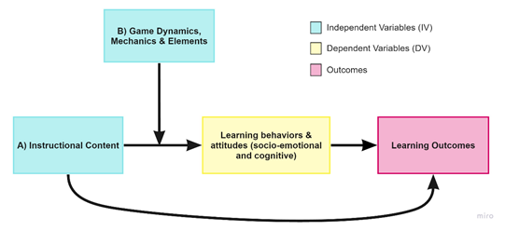
Figure 1. Theory of Gamification in an Educational Context. This figure illustrates the theorized processes of gamification on learning outcomes. The arrows represent the theorized causal effect of each construct.

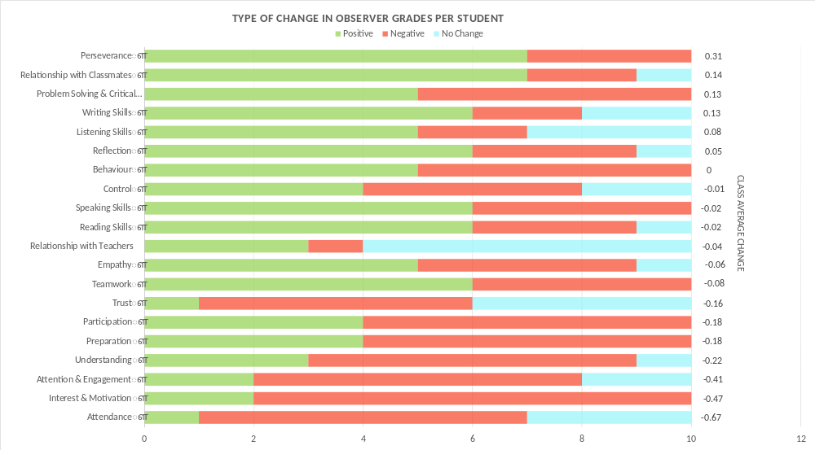
Figure 2 Bar graph displaying the number of students per category that had a positive and negative change in grade. Students with positive change can be found in green, negative change in red, and no change in blue. On the Y-Axis, the average change in class grade is also presented.
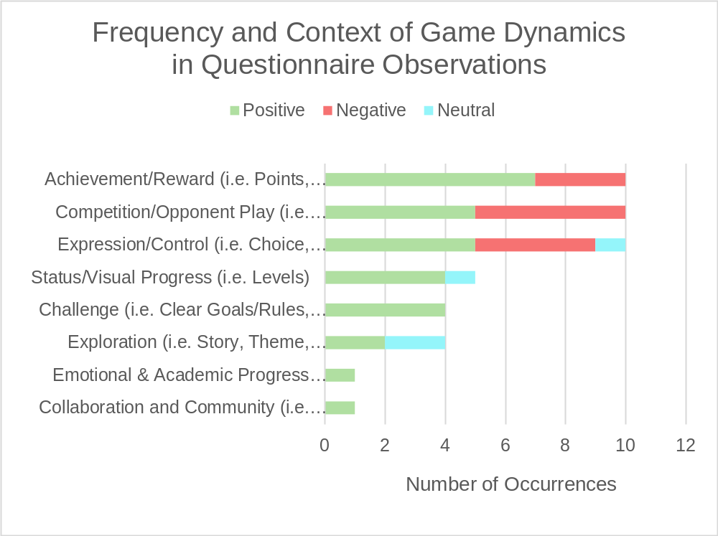
Figure 3 Bar graph displaying the number of positive, negative, and neutral occurrences of game dynamics interpreted from the questionnaire observations. Positive occurrences are represented with green, negative with red, and neutral with blue.

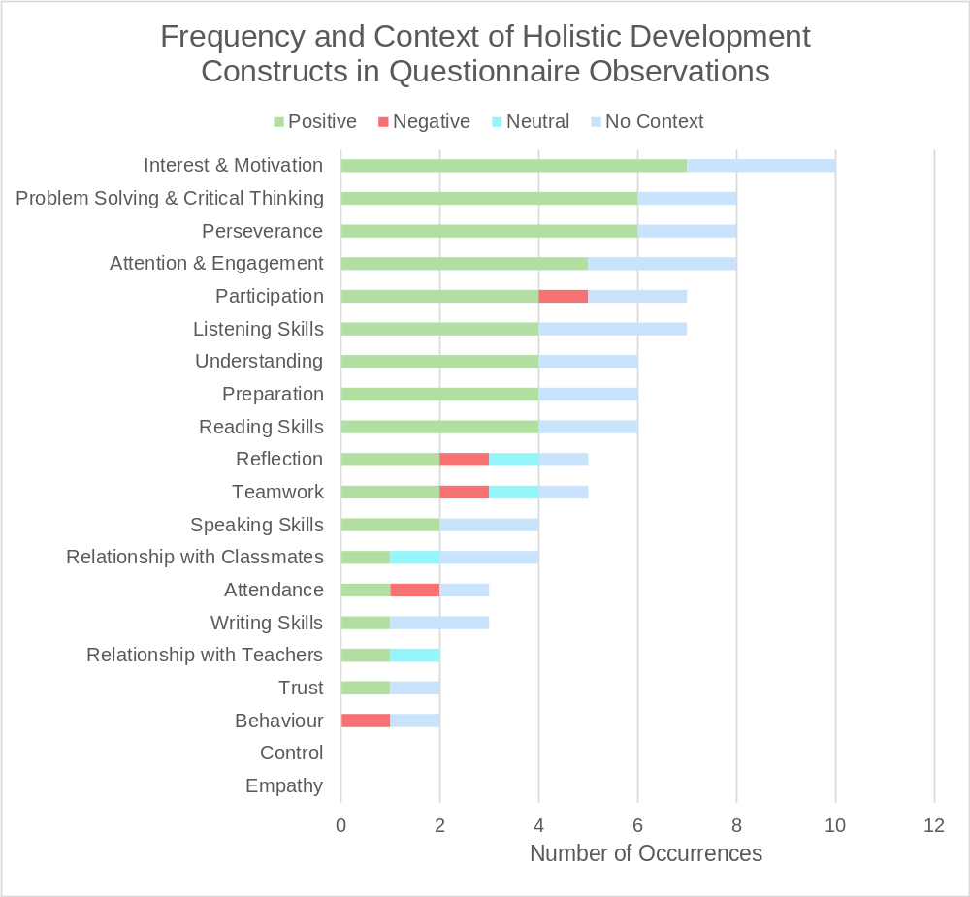
Figure 4 Bar graph displaying the number of positive, negative, and neutral occurrences of holistic development constructs interpreted from the questionnaire observations. Positive occurrences are represented with green, negative with red, neutral with blue and no change with grey.

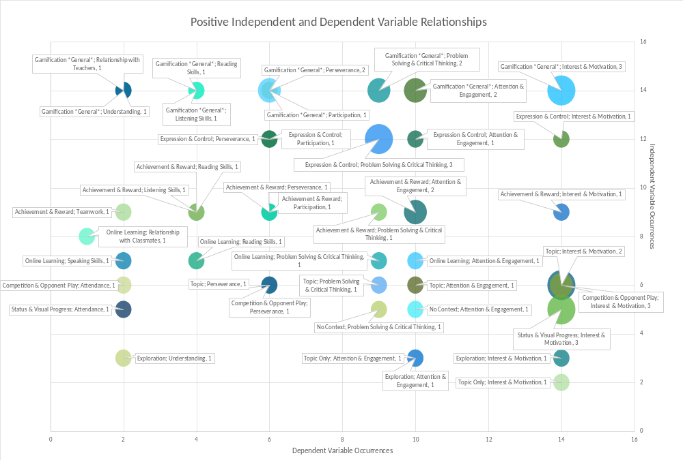
Figure 5 Bubble chart displaying the positive occurrences of independent and dependent variables. As well as the frequency their relationships occurred in observations.
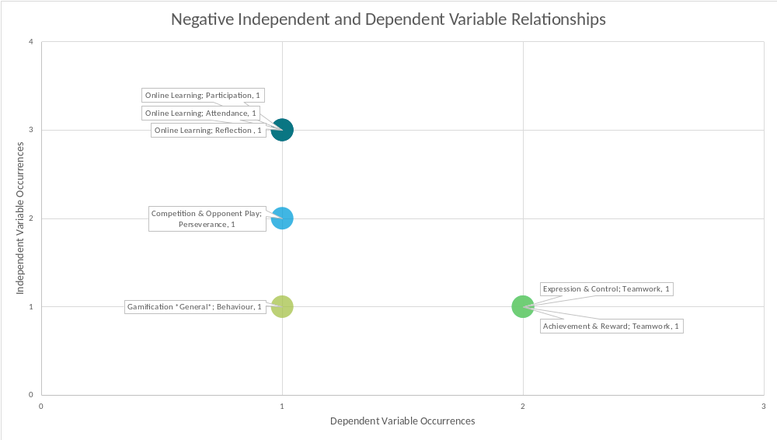
Figure 6 Bubble chart displaying the negative occurrences of independent and dependent variables. As well as the frequency their relationships occurred in observations.

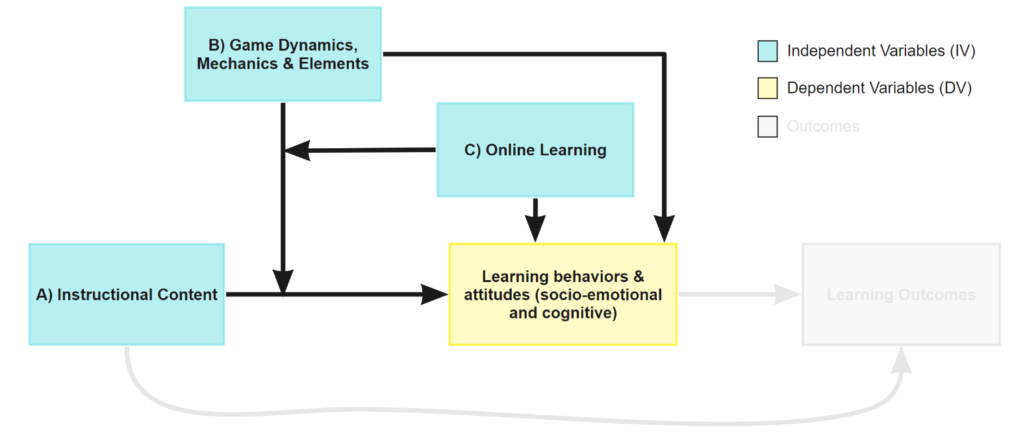
Figure 7. Adjusted Theory of Gamification in an Educational Context. This figure illustrates the theorized processes of gamification on learning behaviours and attitudes observed in this study. The relationships involving learning outcomes are greyed as they were not in the scope of the study. The arrows represent the theorized causal effect of each construct.

References
Akubuilo, F. (2012). Holistic Assessment of Student’s Learning Outcome. Journal of Education and Practice, 3(12), 56-60. Retrieved from https://www.iiste.org/Journals/index.php/JEP/article/view/2880/2906
Bicen, H. & Kocakoyun, S. (2018). Perceptions of Students for Gamification Approach: Kahoot as a Case Study. International Journal of Emerging Technologies in Learning (iJET), 13(2), 72-93. doi:10.3991/ijet.v13i02.7467
Bunchball. (2019, November 12). What are Game Mechanics? Retrieved January 5, 2020, from https://www.bunchball.com/gamification/game-mechanics
Cheong, C., Cheong, F. & Filippou, J. (2013). Quick Quiz: A Gamified Approach for Enhancing Learning. PACIS 2013 Proceedings. AIS Electronic Library (AISeL). Retrieved from https://pdfs.semanticscholar.org/665a/085468543f51c8bb7708aad7f01ae46e2236.pdf?_ga=2.164002431.1952443198.1579022778-1705834898.1579022778
Cobb, W., Durrant, J., Hope, G., Howells, K., Gregory, P., & Wilson, V. (2016). Researching Primary Education. (R. Austin, Ed.). Thousand Oaks, CA: SAGE Publications Inc.
de-Marcos, L., Domínguez, A., Saenz-de-Navarrete, J., & Pagés, C. (2014, June). An empirical study comparing gamification and social networking on e-learning. Computers & Education, 75, 82-91. doi:10.1016/j.compedu.2014.01.012
de-Marcos, L., Gacia-Lopez, E., & Garcia-Cabot, A. (2016, April). On the effectiveness of game-like and social approaches in learning: Comparing educational gaming, gamification & social networking. Computers & Education, 95, 99-113. doi:10.1016/j.compedu.2015.12.008
Designing Digitally. (2019, April 23). Game Mechanics Versus Game Dynamics. Retrieved December 14, 2019, from https://www.designingdigitally.com/blog/2019/04/game-mechanics-versus-game-dynamics
Fieldwork Education. (2019). Space Explorers: IPC Unit Manual [PDF]. Retrieved May 10, 2019 from fieldworkeducation.com/curriculums/primary-years/ipc
Fieldwork Education. (n.d.). About the IPC. Retrieved November 27, 2019, from https://fieldworkeducation.com/curriculums/primary-years/about-the-ipc
Hanus, M. D., & Fox, J. (2015, January). Assessing the effects of gamification in the classroom: A longitudinal study on intrinsic motivation, social comparison, satisfaction, effort, and academic performance. Computers & Education, 80, (152-161). doi:10.1016/j.compedu.2014.08.019
Hew, K. F., Huang, B., Chu, K. W. S., & Chiu, D. K. W. (2016). Engaging Asian students through game mechanics: Findings from two experiment studies. Computers & Education, 92-93, 221-236. doi:10.1016/j.compedu.2015.10.010
Huang, B. & Hew, K. F. (2015). Do points, badges and leaderboard increase learning and activity: A quasi-experiment on the effects of gamification. In Ogata, H. et al. (Eds.), Proceedings of the 23rd International Conference on Computers in Education (275-280). China: Asia-Pacific Society for Computers in Education. Retrieved from https://www.researchgate.net/profile/Khe_Hew/publication/286001811_Do_points_badges_and_leaderboard_increase_learning_and_activity_A_quasi-experiment_on_the_effects_of_gamification/links/5665404708ae15e746333d22/Do-points-badges-and-leaderboard-increase-learning-and-activity-A-quasi-experiment-on-the-effects-of-gamification.pdf
Humari, J., Koivisto, J., & Sarsa, H. (2014). Does Gamification Work? — A Literature Review of Empirical Studies on Gamification. 2014 47th Hawaii International Conference on System Science (3025-3034). IEEE. doi:10.1109/HICSS.2014.377
Hwang, M., Hong, J., Cheng, H., Peng, Y., & Wu, N. (2013, January). Gender differences in cognitive load and competition anxiety affect 6th grade students' attitude toward playing and intention to play at a sequential or synchronous game. Computers & Education, 60, 254-263. doi:10.1016/j.compedu.2012.06.014
Jagušta, T., Botičkia, I., & Sob, H. (June, 2018). Examining competitive, collaborative and adaptive gamification in young learners' math learning. Computers & Education, 125, 444-457. doi:0.1016/j.compedu.2018.06.022
Kim, B. (2015, February-March). Game Mechanics, Dynamics, and Aesthetics. Library Technology Reports, 51(2), 17-19. doi:10.5860/ltr.51n2
Kim, T. W., & Werbach, K. (2016, June). More than just a game: Ethical issues in gamification. Ethics and Information Technology, 18(2), (p. 1-49). Advance online publication. doi:10.1007/s10676-016-9401-5
Landers, R. N. (2014). Developing a Theory of Gamified Learning: Linking Serious Games and Gamification of Learning. Simulation & Gaming, 45(6), 752-768. doi:10.1177/1046878114563660
Lange, R. T. (2011). Inter-rater Reliability. Retrieved from https://link.springer.com/referenceworkentry/10.1007/978-0-387-79948-3_1203
Lee, J. & Hammer, J. (2011, January). Gamification in Education: What, How, Why Bother?. Academic Exchange Quarterly, 15(2), 1-5. Retrieved from https://www.researchgate.net/publication/258697764_Gamification_in_Education_What_How_Why_Bother
Nicholson, S. (n.d.). A RECIPE for Meaningful Gamification. In Wood, L & Reiners, T. (Eds.), Gamification in Education and Business. New York: Springer. Advance online publication. Retrieved from http://scottnicholson.com/pubs/recipepreprint.pdf
Price, P. C., Jhangiani, R., & Chiang, I. A. (2016). Nonexperimental Research: Quasi-Experimental Research. In Research Methods in Psychology (2nd ed.). Retrieved from https://opentextbc.ca/researchmethods/
Robertson, M. (2010, November 10). Can't Play, Won't Play [Blog Post]. Retrieved October 13, 2019, from https://kotaku.com/cant-play-wont-play-5686393
Simões, J., Redondo, R. D., & Vilas, A. F. (in press). A social gamification framework for a K-6 learning platform. Computers in Human Behavior. doi:10.1016/j.chb.2012.06.007
Singh, C. K. S., Ong, E. T., & Singh, T. S. M. (2019, March). Redesigning Assessment for Holistic Learning. The Journal of Social Sciences Research, 5(3), 620-625. doi:10.32861/jssr.53.620.625
TEDx Talks (2018, May 7). The Power of Gamification in Education: Scott Hebert TEDxUAlberta [Video File]. Retrieved on August 18, 2019, from https://www.youtube.com/watch?v=mOssYTimQwM
Trochim, W. M. K. (2020, January). Quasi-Experimental Design. Retrieved January 14, 2020, from https://socialresearchmethods.net/kb/quasiexp.php
Turan, Z., Avinc, Z., Kara, K., & Goktas, Y. (2016). Gamification and Education: Achievements, Cognitive Loads, and Views of Students. International Journal of Emerging Technologies in Learning (iJET), 11(7), 64-69. doi:10.3991/ijet.v11i07.5455
Villagrasa, S., Fonseca, D., & Redondo, E. (2014, October). Teaching Case of Gamification and Visual Technologies for Education. Journal of Cases on Information Technology, 16(4), 38-57. doi:10.4018/jcit.2014100104
Wellington, J. (2015). Educational Research: contemporary issues and practical approaches (2nd ed.). London: Bloomsbury Academic.
Williams, S. & Hin, L. C. (2015). Holistic Assessment: Creating Assessment with Students. In S.F. Tang, L. Logonnathan (Eds.), Taylor’s 7th Teaching and Learning Conference 2014 Proceedings (p. 389-397). Singapore: Springer Science

Appendix
Data and Materials Available Upon Request
The following data sets or materials were used in this study but were either irrelevant in answering the research question or contained too much information to include. They may be obtained for review by contacting the researcher.
- Holistic Assessment Raw Data
- Questionnaire Raw Data
- Data Coded by Context of Change
- Learning Plan and Designed Gamified Unit

